How to set up CA policy for public/Native/mobile applications

Since Conditional Access policy sets the requirements for accessing a service you are not able to apply it to a client (public/native) application in your case your mobile application. In other words, the policy is not set directly on a client (public/native) application but is applied when a client calls a service.

1. Create one more one more API app registration (This is just a dummy registration) along with the app registration for client app and then expose an API under API app registration.

1. In the client API registration add API permission to the exposed API. Graphical user interface, text, application

   Description automatically generated
2. Create a CA policy as required on the API app registration. This step needs to be done on the tenant from where this application will be accessed.

1. The above action would trigger a CA policy for MFA.

For Multitenant App

1. Create one more one more API app registration (This is just a dummy registration along with the app registration for client app and then expose an API under API app registration. This is to be done only once on the master Tenant , not on all tenants.

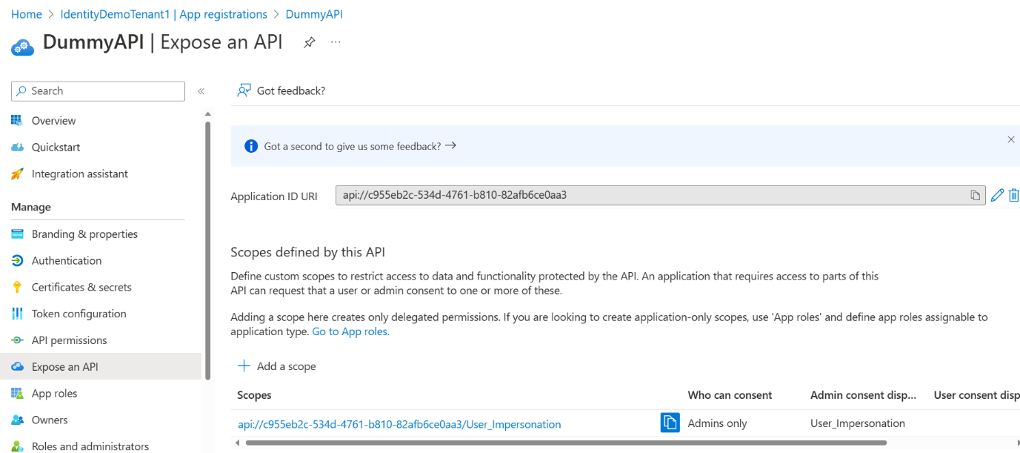

1. In the client API registration add API permission to the exposed API. This is also needed to be done on the master tenant only.

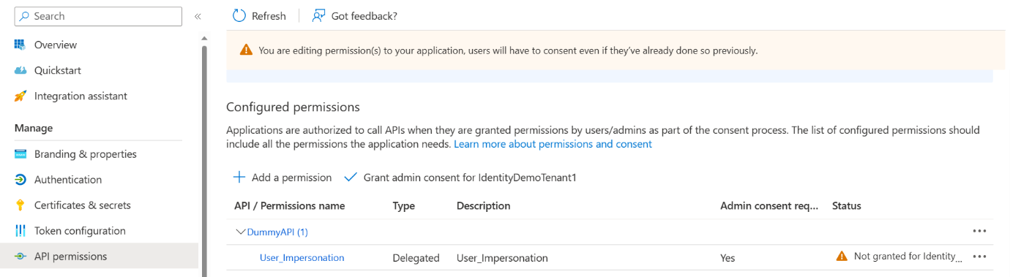

1. Provide admin consent using this URL

[https://login.microsoftonline.com/<TENANT ID of the other tenants not the master> /adminConsent?client_id=281f36b3-1ad6-46e4-bc79-9df6381b0b2f&redirect_uri=https://portal.azure.com/TokenAuthorize](https://login.microsoftonline.com/%3cTENANT%20ID%20of%20the%20other%20tenants%20not%20the%20master%3e%20/adminConsent?client_id=281f36b3-1ad6-46e4-bc79-9df6381b0b2f&redirect_uri=https://portal.azure.com/TokenAuthorize)

1. Once this is done , you will be able to see both the apps under enterprise applications under all the tenants.
2. Create a CA policy as required on the API app registration. This step needs to be done on all the tenants from where this application will be accessed.

1. The above action would trigger a CA policy for MFA.